UWA Computing History Highlights.
The early history of computing at UWA has been documented by Professor Alex Reid, former Director (1979-1991) of the Western Australian Regional Computing Centre (WARCC).
[this website formerly located at http://www.library.uwa.edu.au/about/history-of-computing]

Year | Highlights | Images
1961 | Dennis Moore appointed Officer-in-Charge, UWA Computing Centre.  A transcript of an interview with Dennis as part of the National Library’s “History of ICT in Australia Oral History Project” can be seen HERE. | 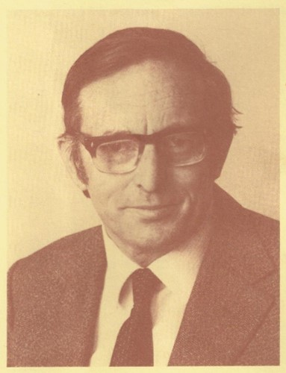
1962 | The IBM 1620 was the first computer in Western Australia and was delivered to UWA in September 1962. The main panel and typewriter of the computer are still intact and have been incorporated into a reconstructed console, which has been on display around the University; in the Science Library late in 2012 as pictured and since July 1st 2013 it has been on display in the Computer Science lobby. | 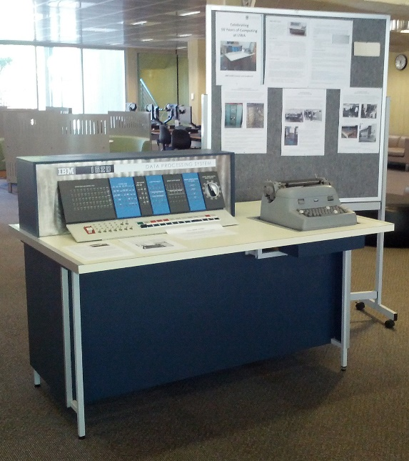
1965 | The Digital Equipment Corp PDP-6 was the first time-shared computer at UWA; it was delivered to the University in May 1965 and became the first commercially-built time-shared computer to be delivered anywhere in the world. When decommissioned in 1973 (replaced by a DEC System 10) it was placed in the Wireless Hill Telecommunications Museum in Melville. Later it was acquired by the Australian Computer Museum Society (WA) and stored in their warehouse in Mundaring. In May 2017 it was acquired by the Living Computer Museum in Seattle for restoration. | 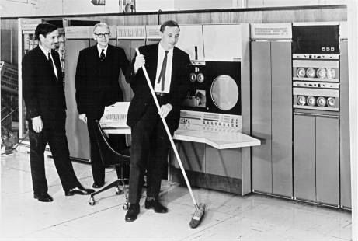
1972 | Western Australian Regional Computing Centre (WARCC) was established in 1972. The CDC Cyber 72 was the first computer of the WARCC, the console of which (pictured) was housed in a UWA store until May 2017, when it was shipped to the Living Computer Museum in Seattle for restoration. WARCC was a unique venture, set up by the University but operated as an autonomous unit, responsible to its Board representing a range of universities, CSIRO and government departments. This sharing enabled a much larger computer to be bought than would otherwise have been possible – the Cyber 72 was one of the biggest computers in Australia at the time. The Commonwealth Government, which at the time funded large computer purchases by universities on a 3-year programme, was eager to induce such sharing, but WA was the only State to do this, and thus was the only State to receive funding in that 3-year period. | 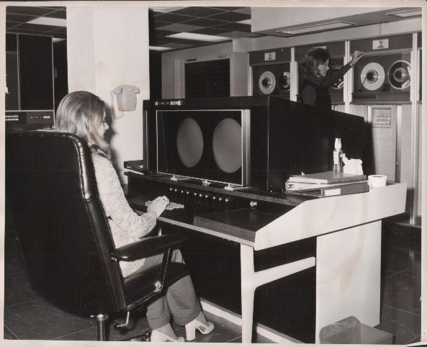
1975 | The Library loans automation system, LOANLY, was introduced into the Reid Library. This was the first system in the world to be self-serve. It also gave access to the catalogue to anyone around (or off) the University who had a terminal connected to the campus network. Alex Reid, its primary designer, wrote a paper about it (see below) which won him the Australian Computer Society Case Study Prize in 1978. | 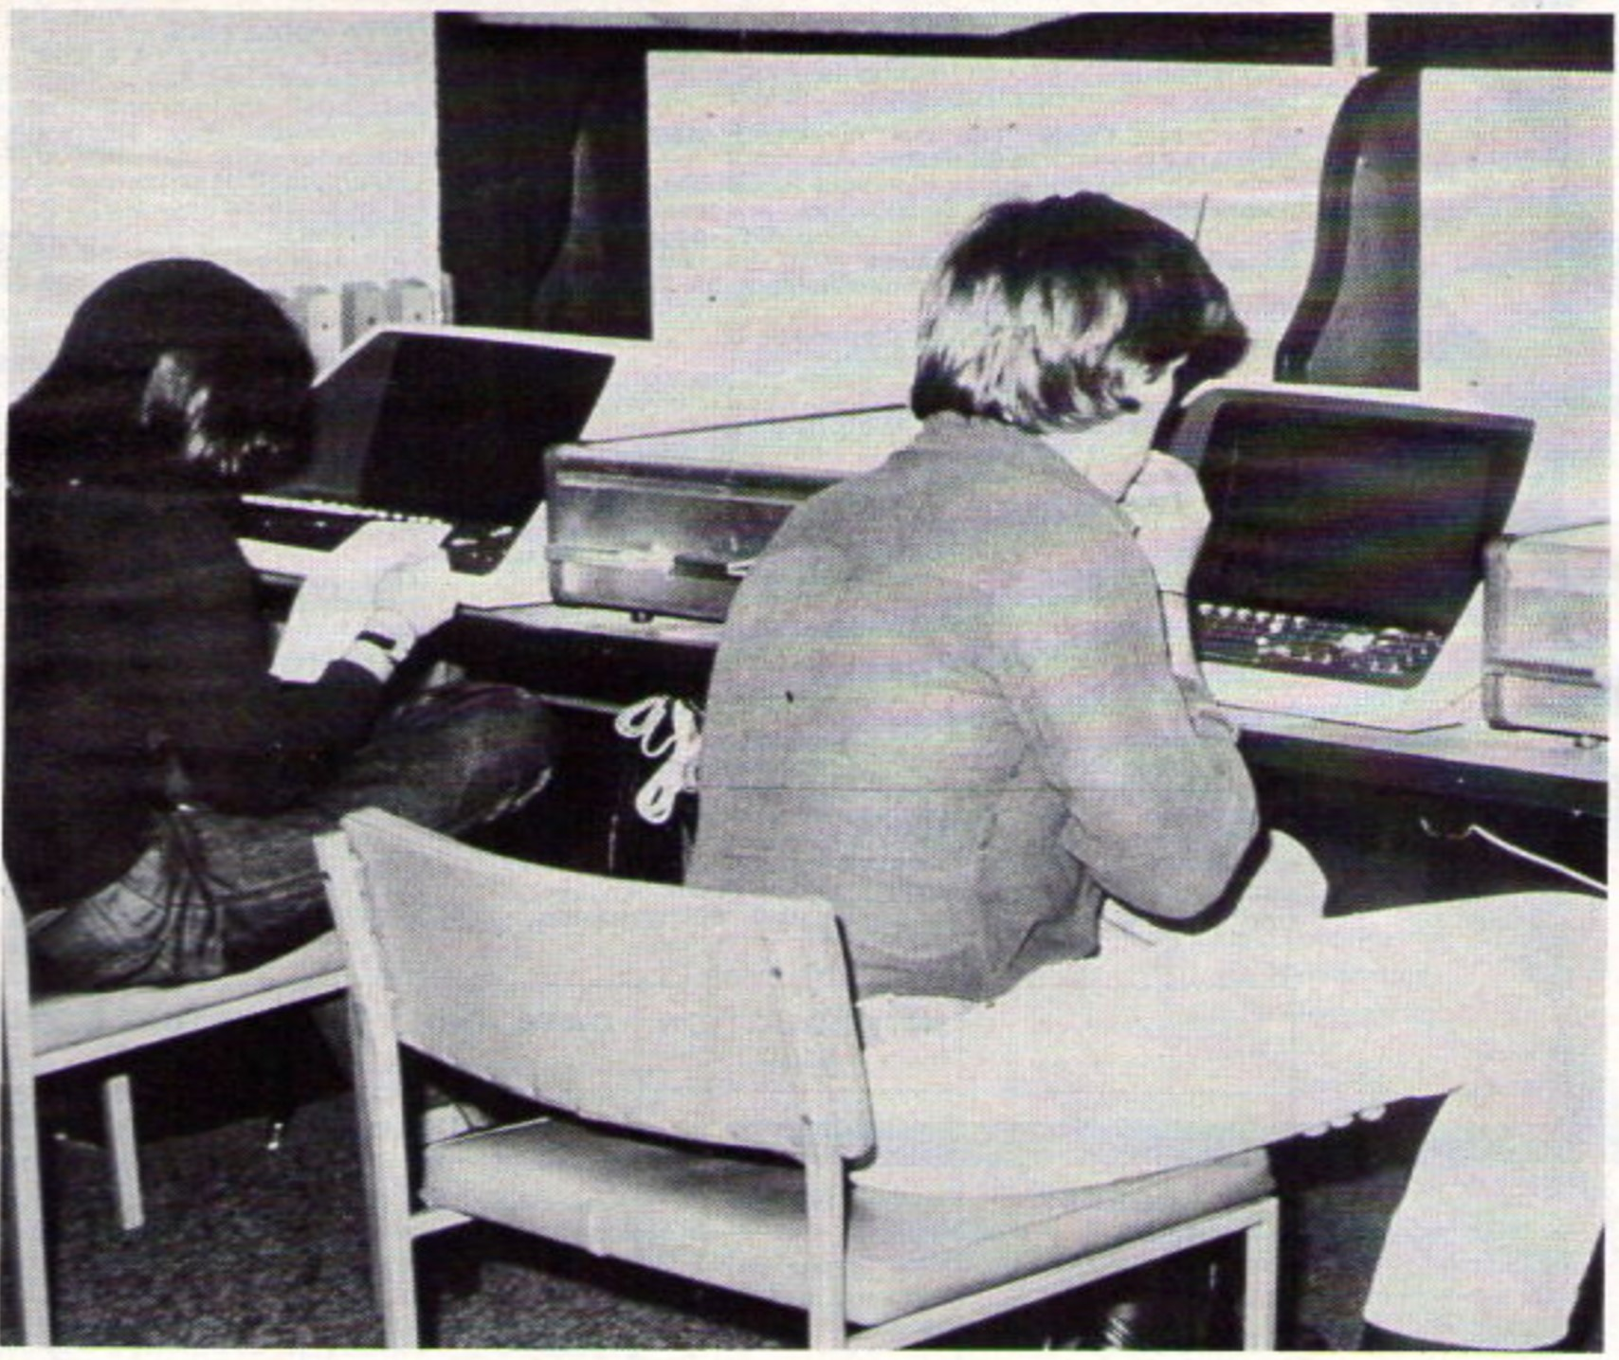
1977 | The Department of Computer Science is established, with Professor Jeff Rohl as its first Head of Department. It takes over all computing teaching, including the Diploma in Computation previously largely taught by members of the Computing Centre (WARCC). | 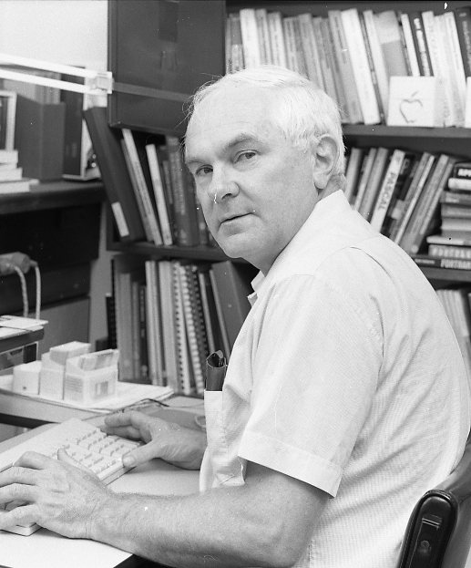
1988 | Status Magazine: reflecting the increasing role that WARCC was playing in technical and scientific computing in Western Australia, in education, government, and in industry, a quarterly magazine was introduced in March 1988, which highlighted some of the more interesting or significant developments across its user base. Copies can be seen at http://www.alex-reid.com/Personal/warcc/Status.html | 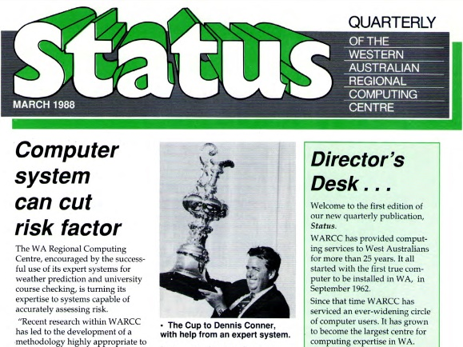
1992 | WARCC is renamed Winthrop Technology and is effectively “spun off” from the University, with the exception of the Network Group under Phil Dufty which formed the nucleus of a continuing University Computing Centre. Winthrop Technology still exists in part, as Winthrop Australia.

Supporting Documents:
• Facts about the IBM 1620 [PDF File, 143.7 KB] Updated: 07 Aug 2013
• Facts about the PDP-6 [PDF File, 383.0 KB] Updated: 07 Aug 2013
• Facts about the Cyber72 [PDF File, 468.5 KB] Updated: 07 Aug 2013
• Australian Computer Bulletin - Feb 1978 [PDF File, 2.1 MB] Updated: 29 Jul 2013
- Transcript of NLA Interview with Dennis Moore, 7-Feb-2015 [HTML file, 300KB] Update 25 Jul 2020

